**Exercise 1: Create Your LifeMap**

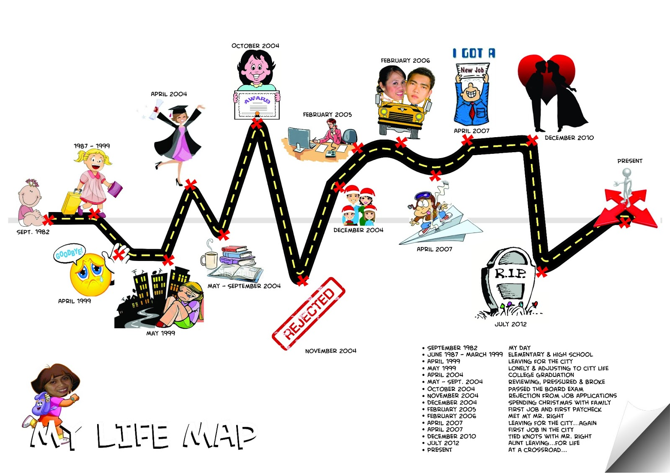

**Instructions:** Draw a map of your life; this map should include whatever experiences, events, places, and people contributed to your life story so far. It should start from your date of birth to where you are now. In doing so, consider where and how you see yourself now.

**Exercise 2: Visioning**

**Picture a day 5 or 10 years in the future…a day you really want. Picture everything about that day: Where you are? Who you are with? What you achieved? How you feel (mentally and physically)? What is the scenery like? How does it look, smell, feel?**

**Describe this day below:**

**Now think about where you are now and work backwards in time to fill in the steps. How did you get there from where you are now? Be as specific as possible. What skills did you have to learn to get where you are that day? Who do meet or connect with who helped you? Who supported you? How did you find the time? How much time did it take? What did you need to practice?**

**Where I am now:**

**Goal (that day in the future):**

Work with a partner. Your partner is a reporter who is interviewing you about the day you envisioned; he/she will ask you questions about how you got there, how you achieved your goal, etc. This will help you see a broader pictuer of what you need to do to achieve your goals. Write down any additional steps that you realize your forgot when you were considering your long-term goal.

**Exercise 3: The Next Step**

**S**pecific – the goal or task must be specific (example: I need to learn to handle my bike better)

**M**easurable – you must be able to measure the result (example: I am going to spend 30 min a week practicing handling skills including picking up water bottles, cornering, ascending, descending)

**A**chievable – based on the knowledge, tools, skills, and resources you currently have available, you feel you are capable of achieving the task you set for yourself. (example: I have a bike and I have basic riding skills)

**R**easonable – can the step be done at this time? (Example: I have time on the weekends to dedicate to this)

**T**imely – include a “by when” component (example: I can do this once a week for the next month)